**Cape Flats Chronicles: Prototype Design Document**

# 1. Core Concept, Theme & Genre:

**Concept:** "Cape Flats Chronicles" is a PC game that uses a narrative-driven approach to raise awareness about the complex challenges faced by teenagers growing up in disadvantaged communities like the Cape Flats, South Africa. Players take on the role of Lindiwe, a teenager navigating choices that impact her education, relationships, and safety.

**Theme:** Social awareness, resilience, consequence of choices, importance of education, breaking the cycle of poverty and crime.

**Genre:** Interactive Drama/Simulation

**Approach to Awareness and Empathy:**

* Players experience the challenges firsthand through Lindiwe's eyes.
* Actions and task completion directly influence the narrative and character relationships, highlighting the impact of decisions.
* Positive role models within the story showcase alternative paths and community upliftment initiatives.

# 2. Core Gameplay

This section outlines the core gameplay mechanics for "Cape Flats Chronicles."

**Movement and Controls:**

* The game utilizes a 3D perspective. Players use WASD keys for movement and the mouse to look around and interact with objects/NPCs.

**Objectives:**

* Complete tasks assigned by the teacher to improve Lindiwe's educational status.
* Make moral choices through actions and task completion, influencing Lindiwe's character development.
* Navigate challenges related to gang violence, poverty, limited educational opportunities, and peer pressure.

**Challenges:**

* **Prioritization:** Without a strict time limit, players must prioritize tasks based on their desired outcome (improve education or succumb to gang pressure).

**Progression:**

* The core system based on actions and task completion influencing stats (education/gang reputation) is important. This system tracks Lindiwe's progress and influences the narrative.

**Consequence System: (To be Added)**

* **Overachieving:** Focusing too heavily on one area can lead to negative events or missed opportunities.
  + **Education:** Neglecting social life and personal needs due to excessive focus on schoolwork could lead to isolation, depression, and potentially impacting grades due to burnout.
  + **Work/Gang Activity:** Neglecting schoolwork to focus on work or gang activity could lead to failing grades and limited future opportunities.

Buildings to add

* **Community Centre:** Opportunities to participate in positive activities, find mentorship, or gain access to resources that can help Lindiwe navigate challenges.
* **Shops:** Balancing work hours with schoolwork to avoid neglecting education, while also providing a way to earn money for supplies or participation in extracurricular activities.

# 3. Core Game Elements:

**Game World:** The Cape Flats, South Africa, represented by a single, fixed map. Key locations within the map will be explorable, including:

* **Gran’s Home:** A small, crowded apartment where Lindiwe lives with her Gran. This is a haven for rest and family interaction.
* **Schoolyard:** The centre of education, where Lindiwe attends classes, interacts with teachers and classmates, and completes schoolwork.
* **Gang Area:** Gang challenges like completing tasks for the gang leader to get gang reputation.

**Character Biography:**

* + Lindiwe (16 years old): A bright and determined teenager living in the Cape Flats with her Gran. She dreams of escaping the cycle of poverty and gang violence through education but faces pressure from potential recruitment from local gangs.

**Challenges and Narrative Integration:**

While the map itself is fixed, the challenges Lindiwe faces will be strategically placed within these locations and will evolve throughout the story:

* **Schoolyard:** Educational challenges like completing assignments, maintaining good grades, and facing peer pressure related to academics or gang involvement.
* **Gang Area:** Gang challenges like completing tasks for the gang leader to get gang reputation.
* **Grans House:** Your grans house is where you will need to either lie or tell the truth to your gran and depending on what you choose your reputation will either go up or down.

**Progression:**

* The core system based on actions and task completion influencing stats (education/gang reputation) is important. This system tracks Lindiwe's progress.

**Narrative Progression:**

* The story will unfold through exploration of these key locations, successfully completing tasks, and the choices players make when faced with challenges. The narrative itself can be linear or offer branching paths based on player decisions.
* This revised approach maintains the core concept of navigating challenges within a disadvantaged community but streamlines the level design for a fixed map with dynamic challenges.

# 4. Core Game Mechanics

* **Task Management:** Players complete tasks assigned by the Teacher (homework, projects) and the Gang Leader (errands, community service). Completing tasks will influence educational and gang reputation stats.
* **Status Management:** Players needs to watch our on which Status she is increasing, as both have an ending if a certain limit is reached first

# 5. User Interface (UI)

The UI will be basic and uncluttered to avoid overwhelming the player. There will be two key elements displayed on-screen:

* **Education Status:** This will be represented by an image and a number, that changes based on the protagonist's educational progress.
* **Gang Status:** This will be represented by a separate image and a number, that changes based on the protagonist's Gang progress.

As our game focuses on Building the stats of Lindiwe we created 2 stat icons on the top right-hand Corner. One represents her stats for education and the other represents her stats for criminal activities.

The icon with the skull on the right represent the gang activity icon, and NPC’s with that icon represent gang members. They will offer you task to that involve any sort of criminal activities.

The icon with the scholar hat, represents Lindiwe’s education stats. As the saying goes “Education is the key to success” further increasing this stat will increase her chances of creating a better life for herself and her family, escaping the struggles of poverty through education.

NPC’s will the scholar icon will offer Lindiwe education tasks, that will further increase her scholar stat.

## Dialogue Ui

We had a view idea on how the dialogue Ui should look

At first, we wanted to go with something like this, where we had a speech bubble. The NPC dialogue would show in the speech bubble to give of a sense of the character speaking and have options underneath for the player to choose from to reply back to the character. Also have the icon on the side to represent which sort of NPC it was. The icon will tell the player what type of NPC the player is talking to, they would decipher the type of tasks that would be given to them based on the icon.

We decided to go with a simple approach basically on the visual of the Ui. We removed the speech bubble and as you can see this NPC doesn’t have an icon. This tells you that this is a normal civilian within the game world, who you will not receive any tasks from.

This NPC has a skull icon, this tells us the character is a gang member. A gangster that will give criminal tasks to increase Lindiwe’s skull stat.

This icon represents the NPC is a character that will increase Lindiwe’s scholar stats. A teacher that will give her educational tasks.

# 6. Concept art of game assets

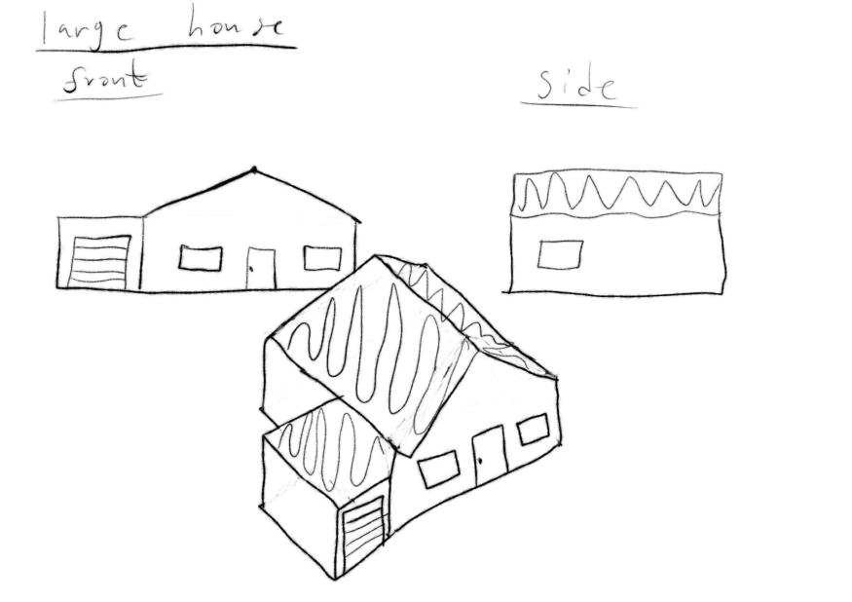

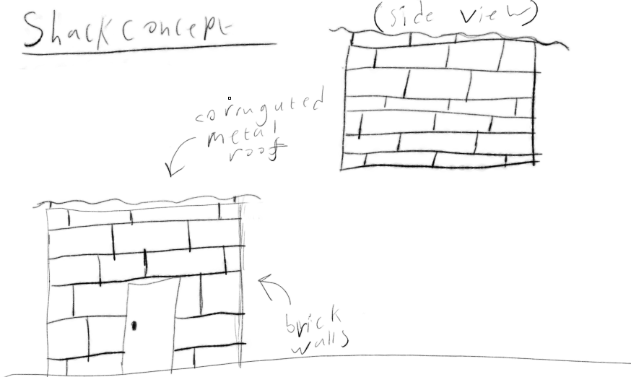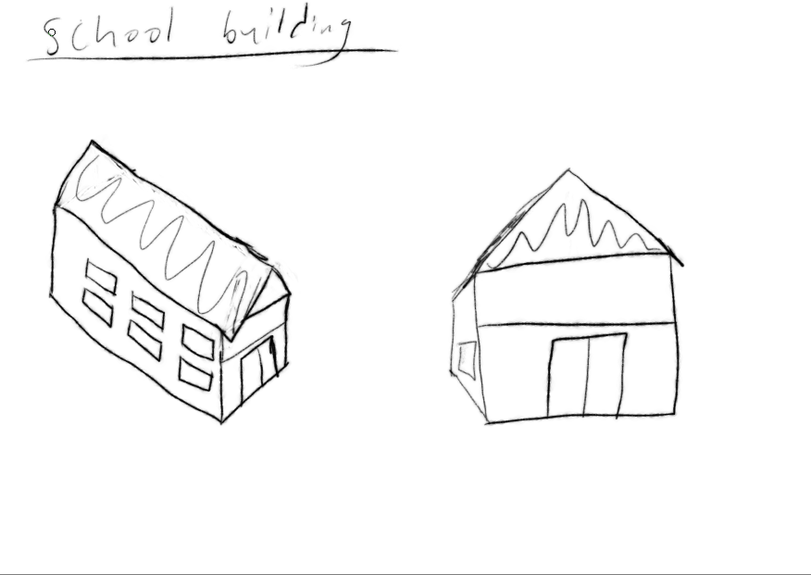

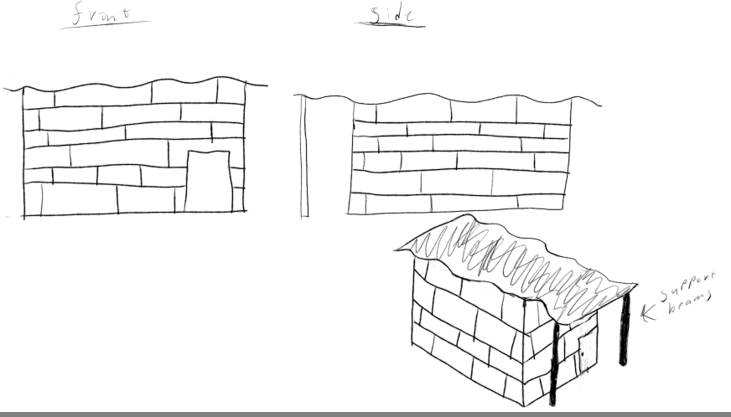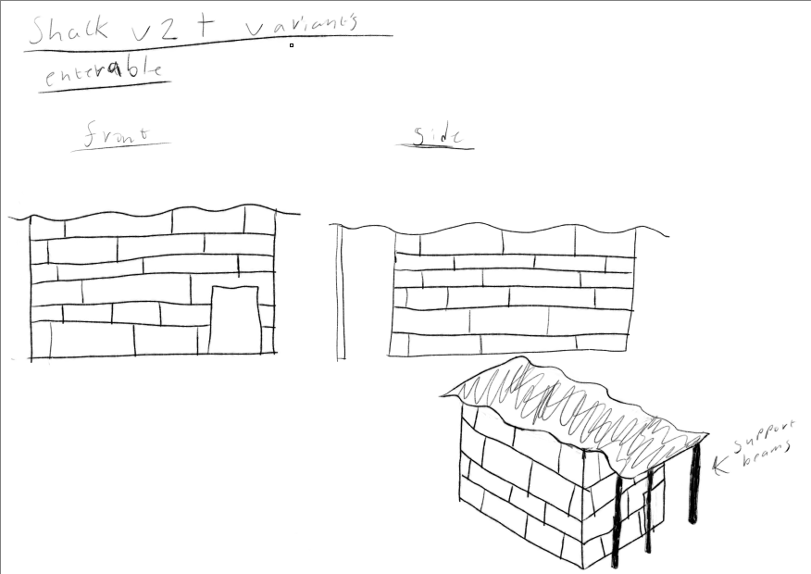

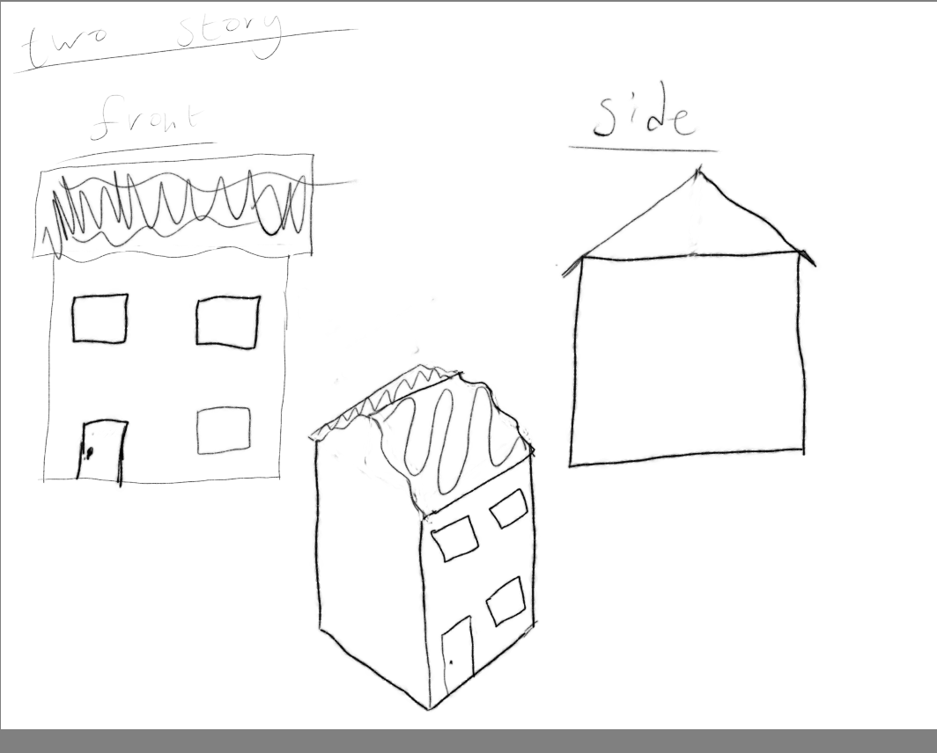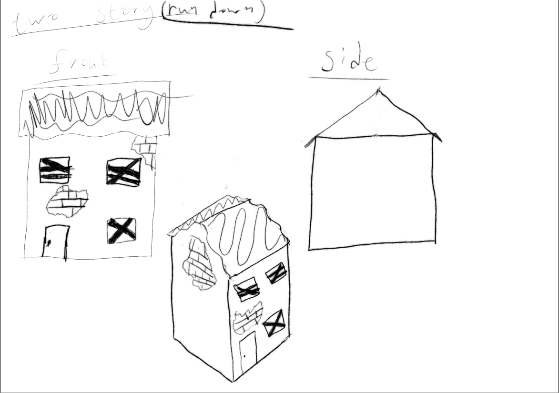

# 7. Concept art of game characters

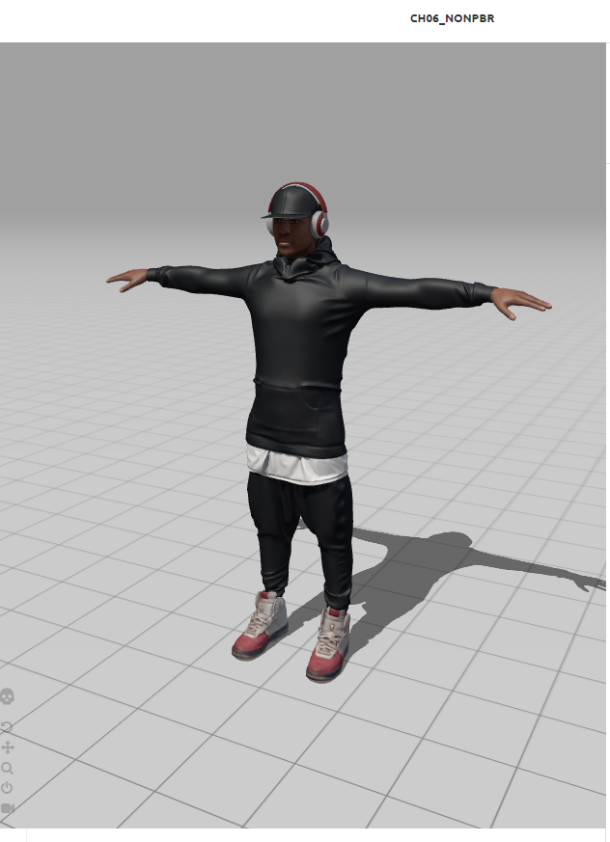Used [www.mixamo.com](http://www.mixamo.com)

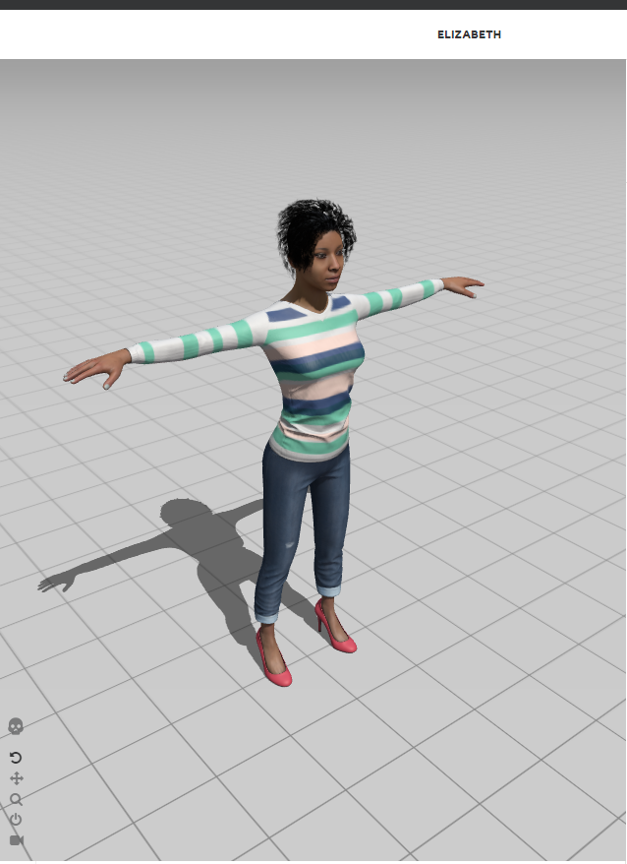

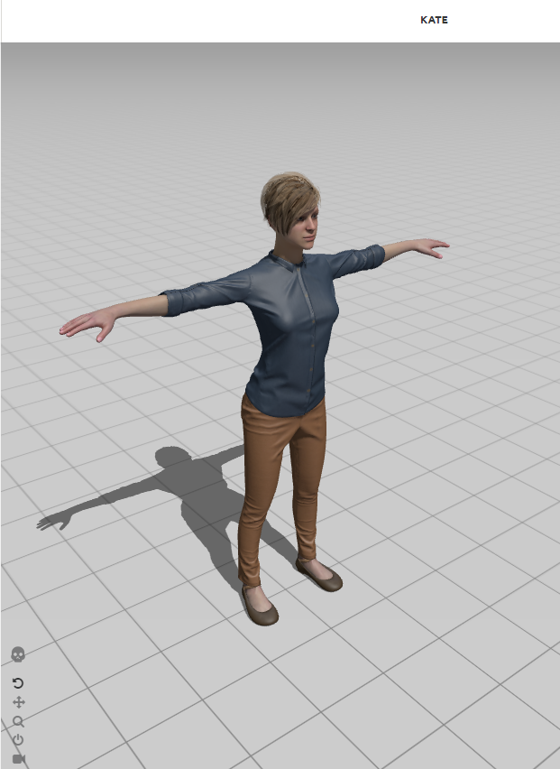

# A drawing of a street Description automatically generated8. Concept art of the game world



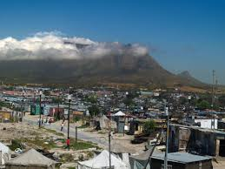

# 9. Description of sound effects, music

The sound design in "Cape Flats Chronicles" aims to create a realistic and immersive experience that reflects the complexities of life in the Cape Flats. It will balance the vibrant community spirit with the ever-present danger of the environment.

**Soundscape:**

* **Ambient Sounds:** Background noises like birds chirping and rain will create a sense of place and enhance immersion.

**Character Interaction:**

* **People Talking:** NPC conversations and background chatter will add life to the world, provide narrative context, and potentially offer clues to the player.
* **Interactive Sounds:** Audio cues will confirm player actions, like picking up items or navigating menus.

**Environmental Effects:**

* **Cars Hooting:** The sounds of cars driving by will enhance the realism of the urban setting.
* **Gunshots:** Gunfire used strategically can signal danger zones or gang activity.

This thoughtful use of sound effects will draw players deeper into the world of "Cape Flats Chronicles," fostering a sense of presence while conveying the realities of the community.

# References

Sa-venues. [s.a.]. CAPE FLATS. [s.a.]. [Online]. Available at: <https://www.sa-venues.com/attractionswc/cape-flats.htm>

[Accessed 10 June 2024]

Colby. [s.a.]. Cape Flat Townships. [s.a.]. [Online]. Available at: <https://web.colby.edu/ragastal/travels/south-africa/cape-flat-townships>

[Accessed 10 June 2024]